Student | Student Name: __________________ ____________________ _______  Last Name First Name MI  Home Phone: __________________Cell Phone: ____________________  Email Address: __________________ SSID#: ______________________  Responsible Parent/Guardian: __________________________________  College: ____________________ College SID #:____________________ |  | ☐Check if this is a revision MI  ☐New Student  ☐Returning Student  ☐Student Enrolled in Multiple Colleges  ☐Spring Quarter Eligibility Adjustment  Form (SQUEAF) attached
 | Free and Reduced-Price Lunch (FRPL) Status (required to be completed for 2020-21 school year)  Students who are currently FRPL eligible (or anytime in the past five school years) may receive tuition and fee waivers from a college.  Is the student currently eligible for FRPL? ☐Yes ☐No HS Counselor Initials: _________  The parent or guardian signature below provides permission to share FRPL eligibility status only with the Running Start college for the purpose of ensuring access to tuition and/or fee waivers. Choosing not to sign the consent will not affect the student’s eligibility for access to Running Start or free and reduced-price meals or free milk. The individuals and programs receiving the information will not share the information with any other entity or program.  Parent/Guardian Signature:______________________________ Date:_____________  School Yr:____________________ College Term: ☐ College Quarter ☐College Semester  High School: _________________________ _________________________  Fall, Winter, Spring Qtr./1st or 2nd Sem.  District: _________________________ Grade Level: ☐Jr ☐Sr ☐ 5th Yr Sr  For the college term above, the student will be enrolled in high school and skill center classes equating ______full-time equivalent (FTE). Student may register for a maximum of _______ college credits, without incurring college tuition costs, based on the above state high school/skill center FTE.  Comments: _____________________________________________________________  _______________________________________________________________________  _______________________________________________________________________ |  |  | 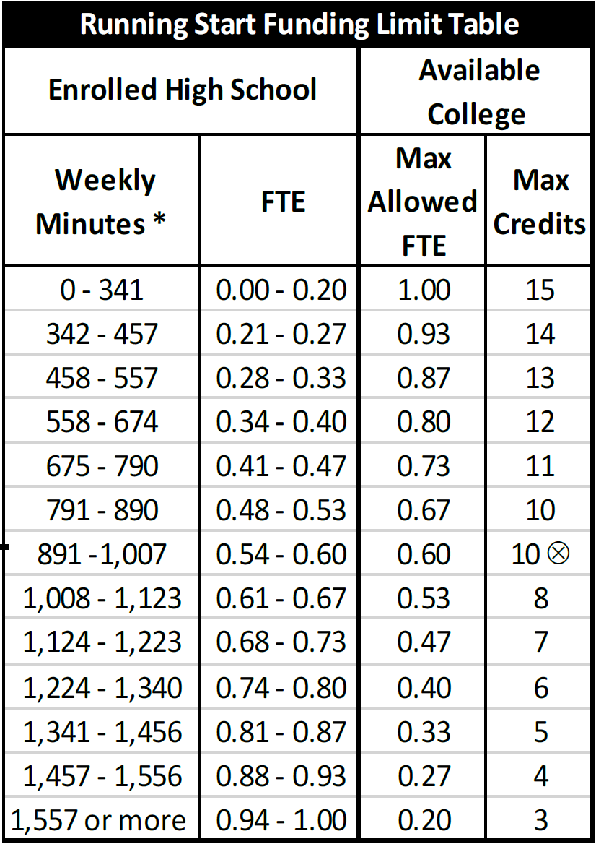
Recommended Running Start Classes:
College Course (Dept. & Number) | # of College Credits |  | High School Equivalency | #of HS Credits
College Class | College Credit | = | HS Equiv. | HS Credit
College Class | College Credit | = | HS Equiv. | HS Credit
College Class | College Credit | = | HS Equiv. | HS Credit
College Class | College Credit | = | HS Equiv. | HS Credit

__________________________________ _______________ __________________________________ _______________
Signature of High School Counselor Date Signature of College Running Start Advisor/Rep Date

__________________________________ _______________ __________________________________ _______________
High School Counselor Name Printed Phone Number College Running Start Advisor/Rep Printed Name Phone Number
I understand that:
- The student is responsible for understanding when his or her choice of schedule will result in tuition charges. If the student enrolls for more high school and college credits than are identified in the Running Start State Funding Limit Table, the student is responsible for:
  - paying all college tuition and fees associated with exceeding the college credits identified in the table; or
  - withdrawing from the excess college or high school course(s).
- The student is required to pay any class/lab fees charged for college classes.
- Enrollment in specific college classes cannot be guaranteed – even if the classes are needed to fulfill high school graduation requirements.
- To add/withdraw from a course, the student must complete the college Add/Drop process by the college deadline and notify the high school counselor.
- The student is responsible for ensuring that college courses completed as part of the Running Start program will meet high school graduation requirements.
- If the student plans to transfer, it is the student’s responsibility to determine college admissions policies/deadlines and whether credits will transfer.
- The student and parent’s signatures below provide permission for the high school and college to share the Running Start student’s academic records, which can include the student’s grades, billing, registration, and attendance records regardless of whether FERPA rights belong to the student or parents.
- After completing the college coursework, students are responsible for requesting official college transcripts through the college’s registrar office. I acknowledge that I have read and understand both sides of this form, and will comply with the conditions of Running Start participation and the expectations of college course enrollment.

__________________________ ___________ ____________________________ __________
Student Signature (REQUIRED) Date Parent/Guardian Signature (REQUIRED) Date
FORM SPI 1674 (4/2020) This is a two page form, with the details and instructions printed on page 2. Questions: Students & Parents contact local high school; High school & college staff, call OSPI at 360-725-6300.
High School Counselor & Running Start Advisor/Rep
Student & Parent/Guardian

